***Client Form Login Credentials:***

***Client Form Creation Users:***

* ***Karachi Branch:***

***Username :*** WaqarKhan (**Producer**)

***Password:*** Waq123

***Username :*** FARMAN    (**Branch Manager**)

***Password:*** Fam_929

* **Karachi Zonal*:***

***Username :*** IRSHADKZ (**Producer**)

***Password:*** irs123

***Username :*** ZAMINKZ (**Branch Manager**)

***Password:*** Zaz_117

* **Imperial*:***

***Username :*** ALIABBAS (**Producer**)

***Password:*** ai123

***Username :*** ISHAQ (**Branch Manager**)

***Password:*** ish123

***Client Form Approval Users:***

* ***Bussiness Rate Approval:***

***Username :*** FAWWADD

***Password:*** Dol58351

***Username :*** Tariq

***Password:*** Hob28848

***Username :*** OMARZUBAIR

***Password:*** Gug38594

* **Over Commission  *Approval:***

***Username :*** MURTAZA.H

***Password:*** Dap08967

* ***Credit Terms /Installment Approval:***

***Username :*** ZEESHANLILANI

***Password:*** zee123

* **AML/Compliance**

***Username :*** SOHAIB

***Password:*** Sohaib123

* **IT**

***Username :*** IT

***Password:*** It123

**Access Link:** <http://192.168.21.2:8889/clientform/>

***New Client Form :* Login for Producer:**

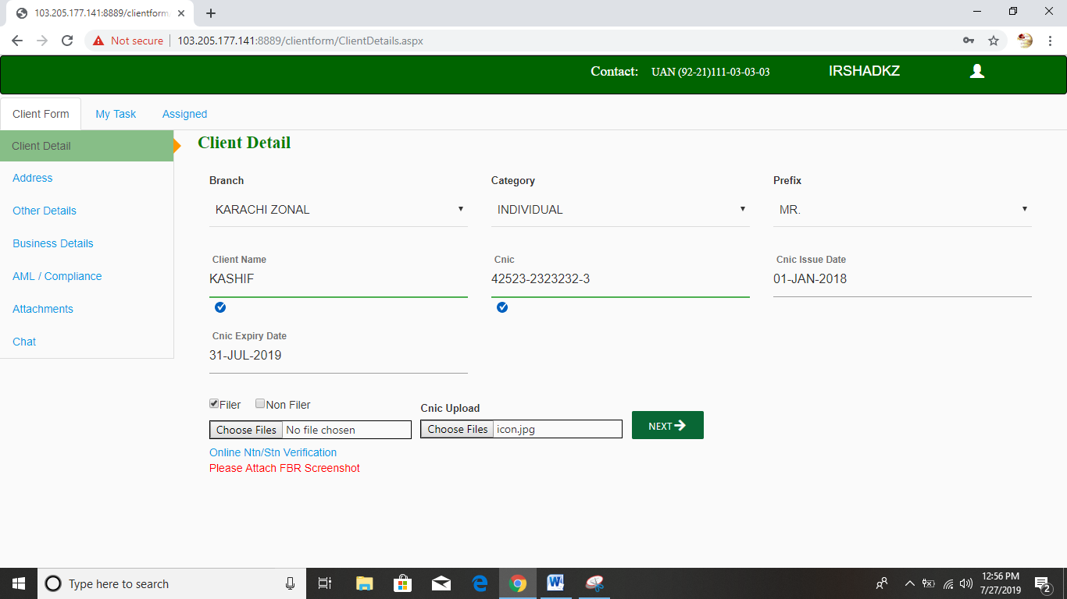

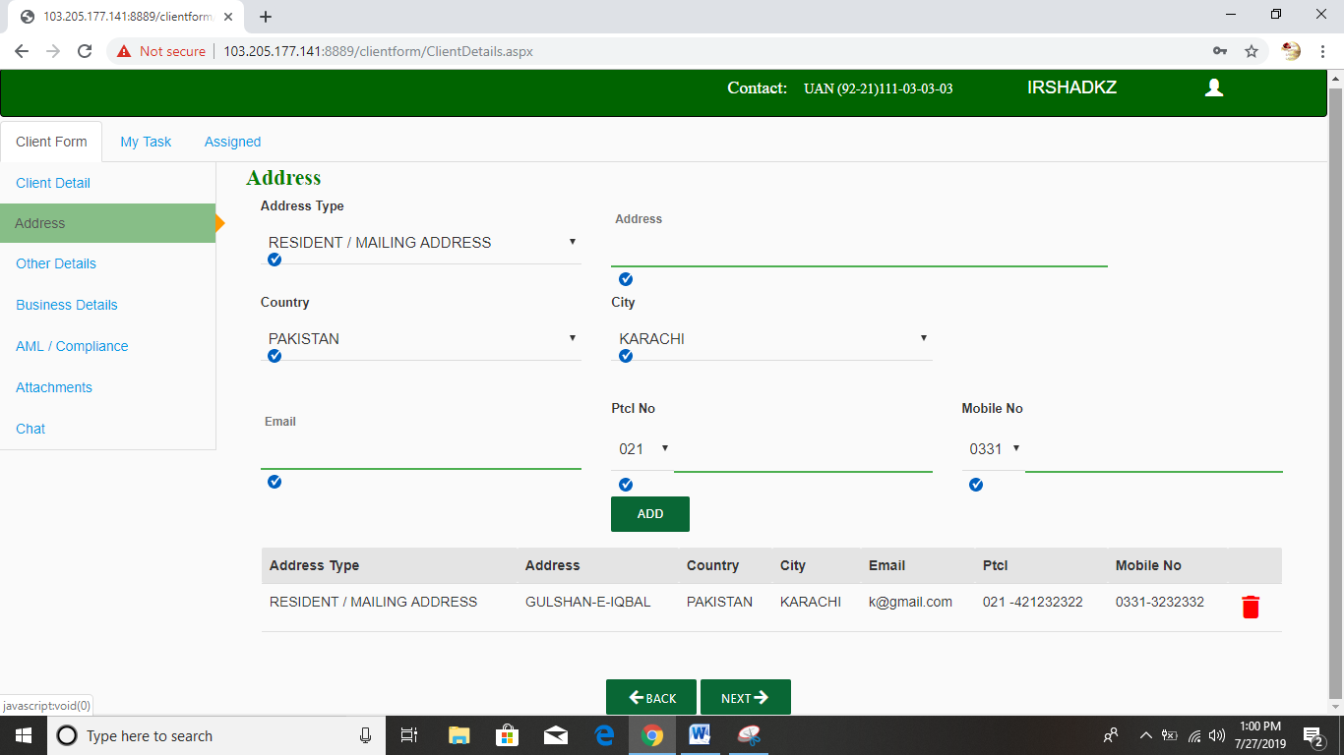

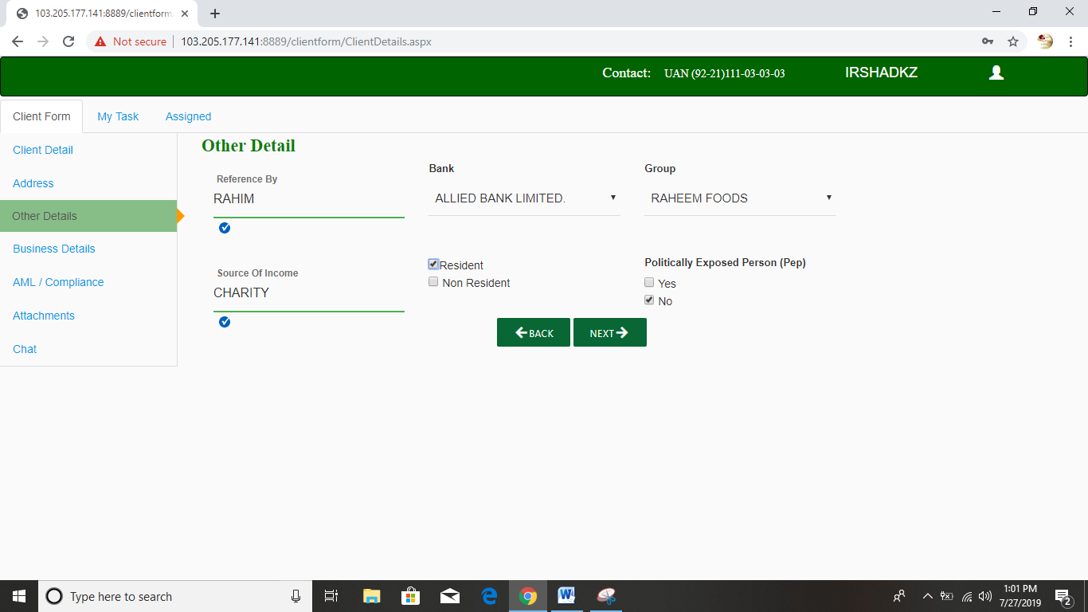

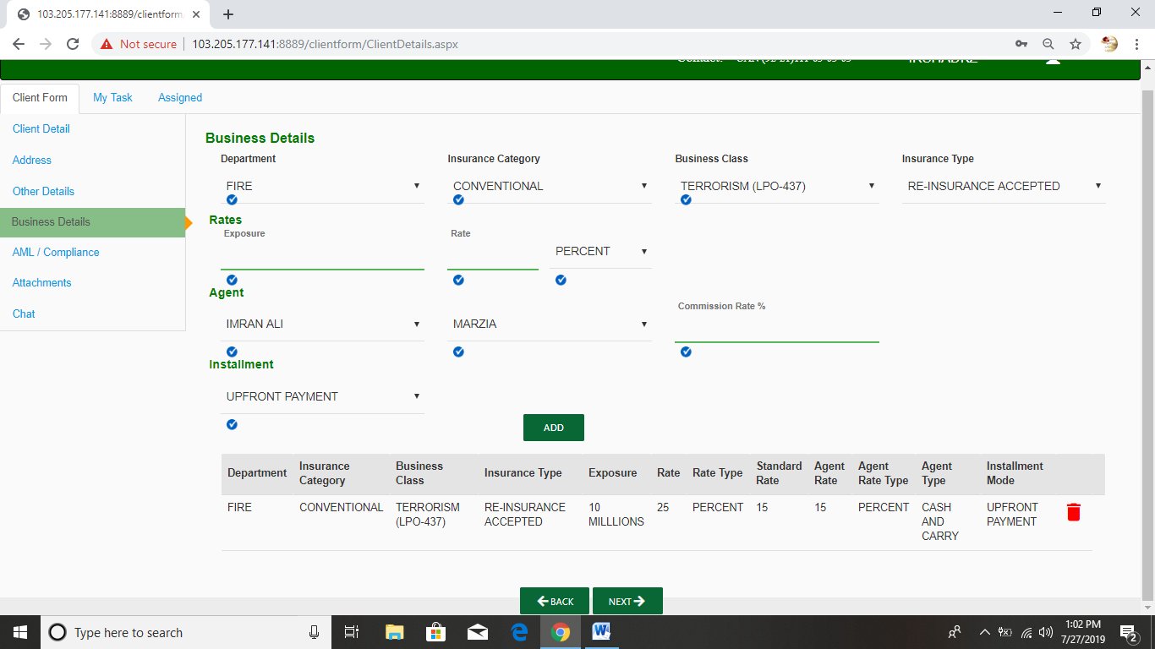

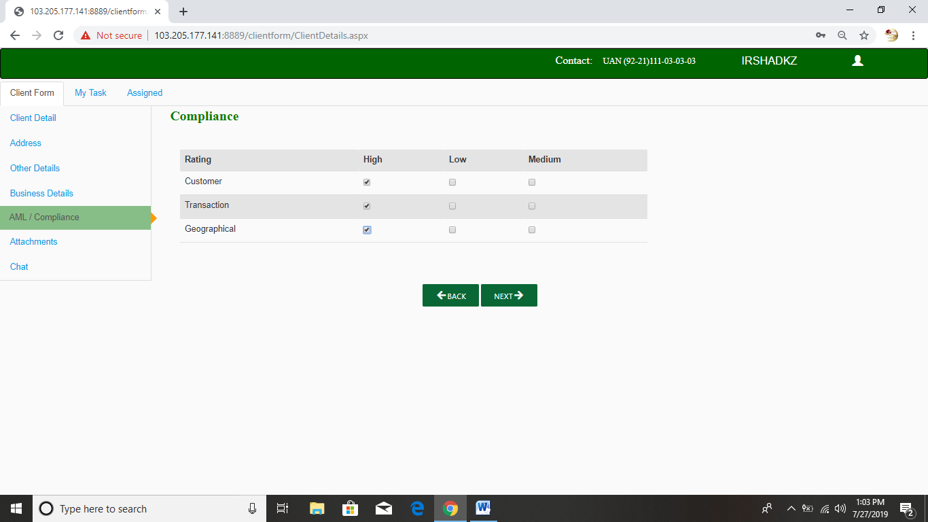

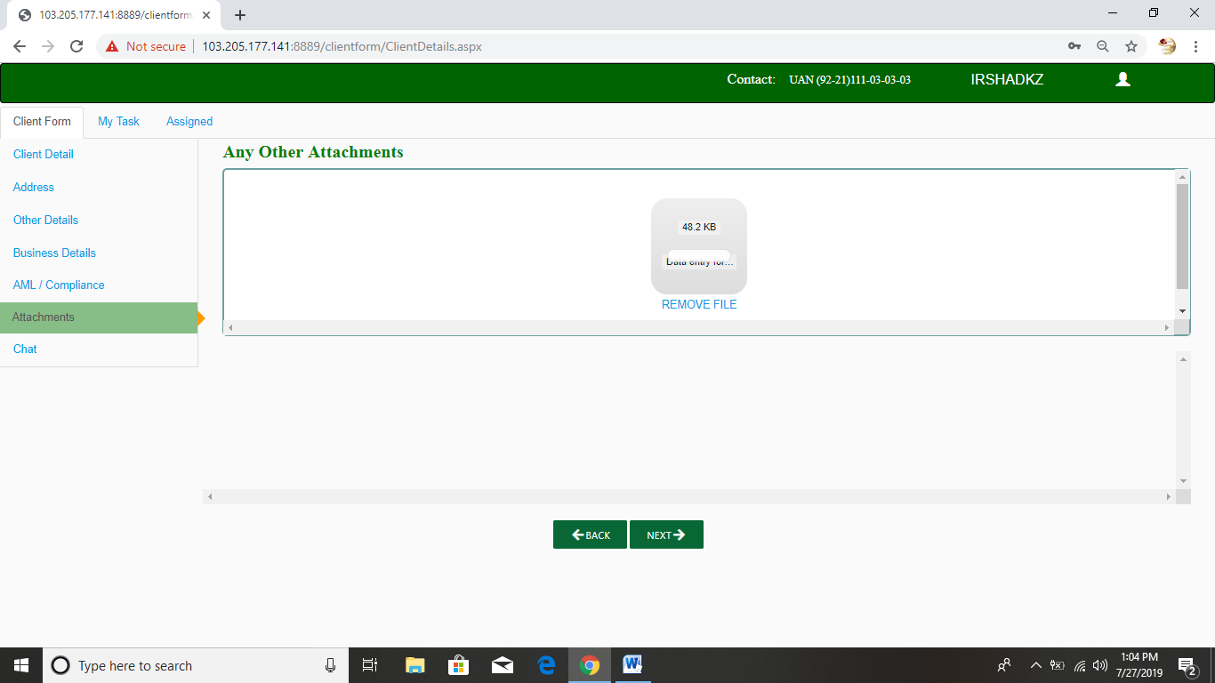

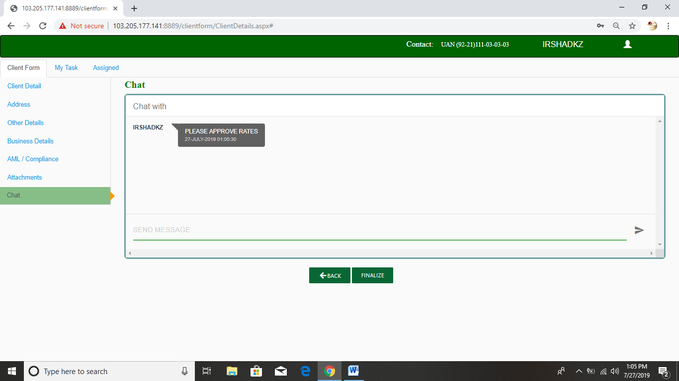

* Producer can fill all details and finalize, then forward to Branch Manager.
* New client request show in My Task tab.

**Login for Branch Manager**

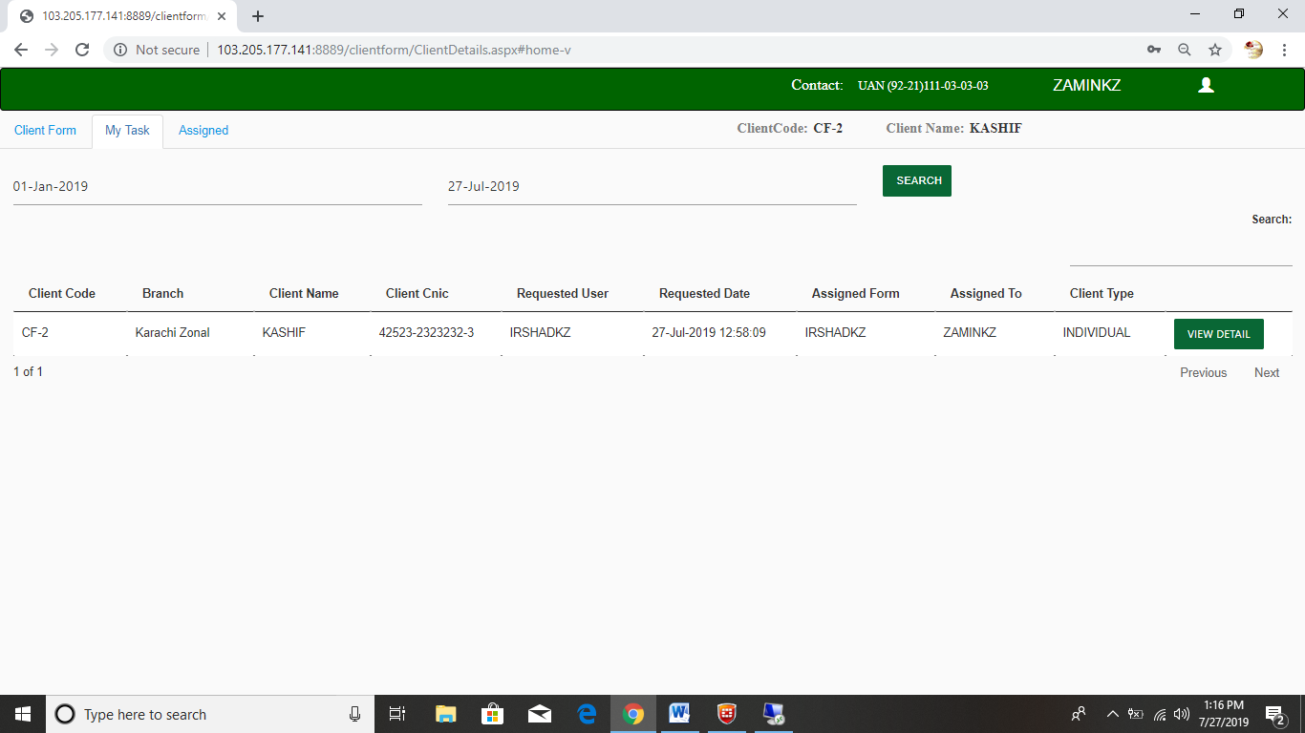

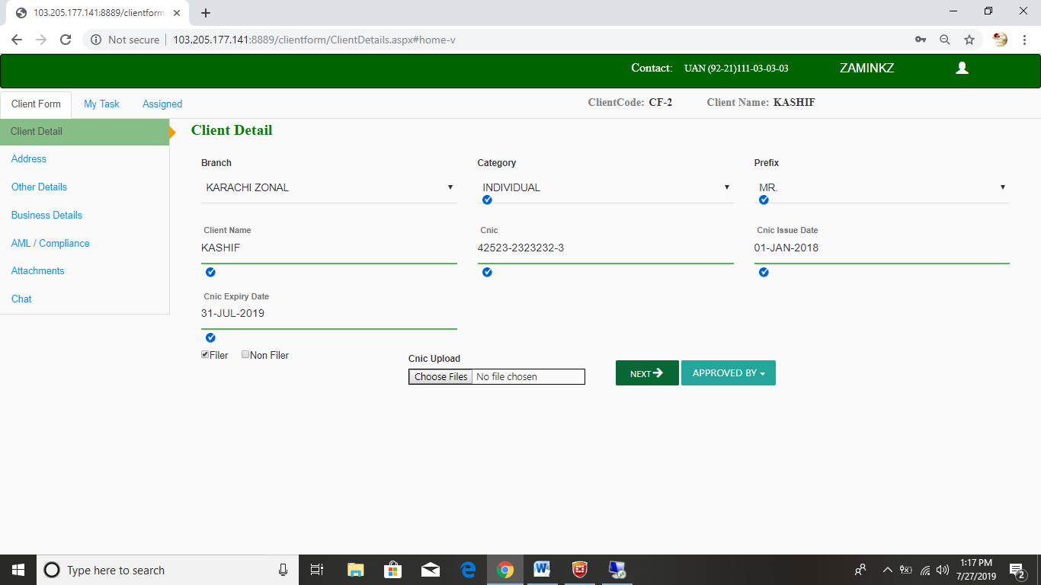

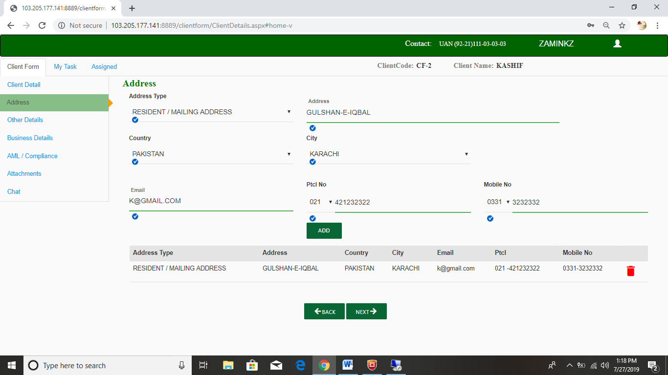

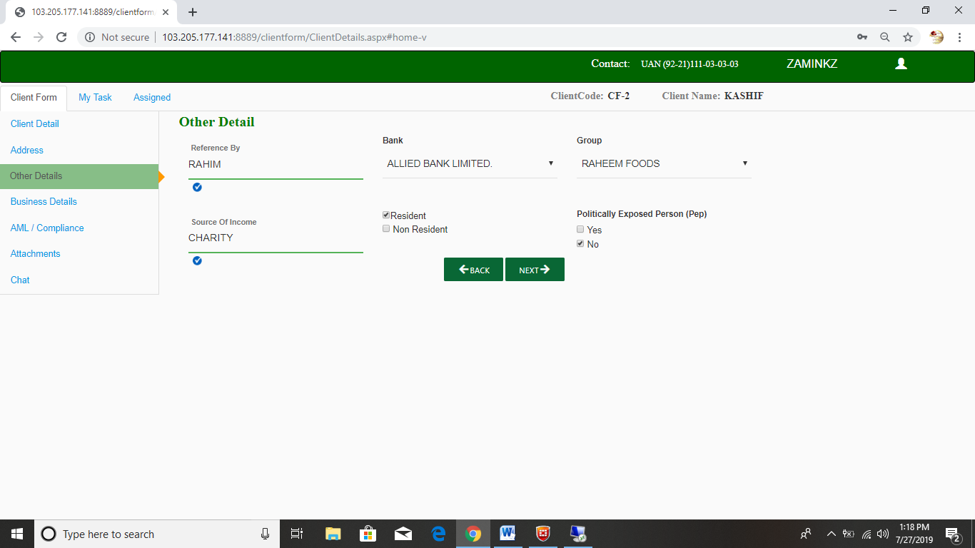

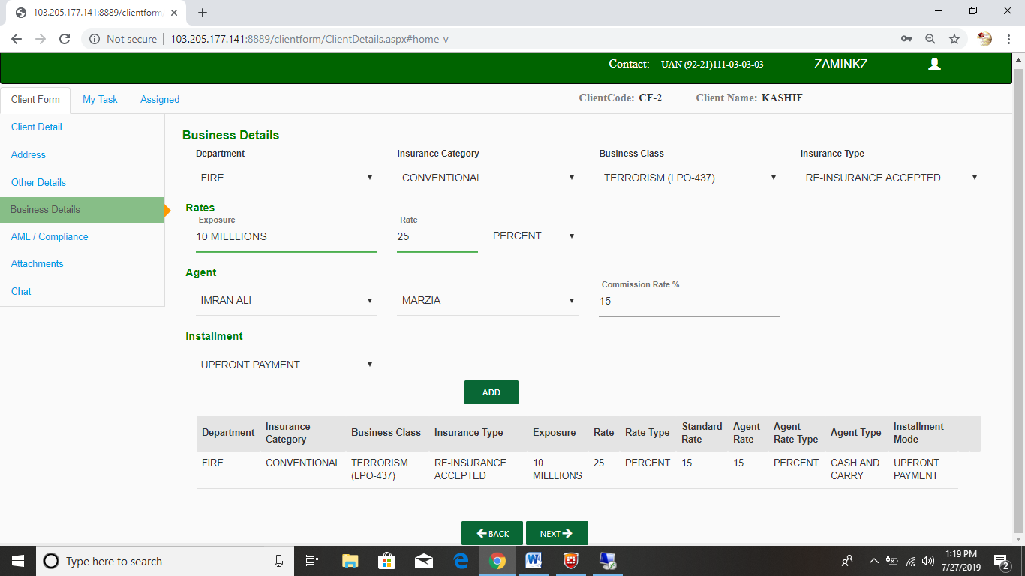

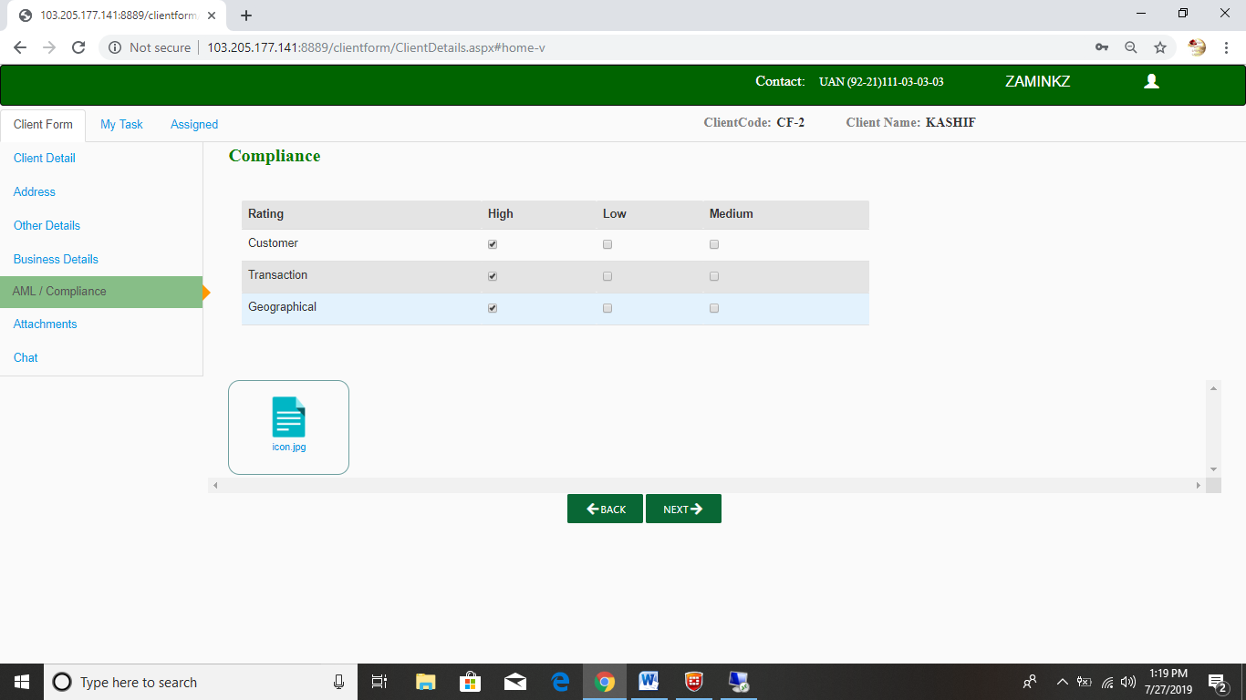

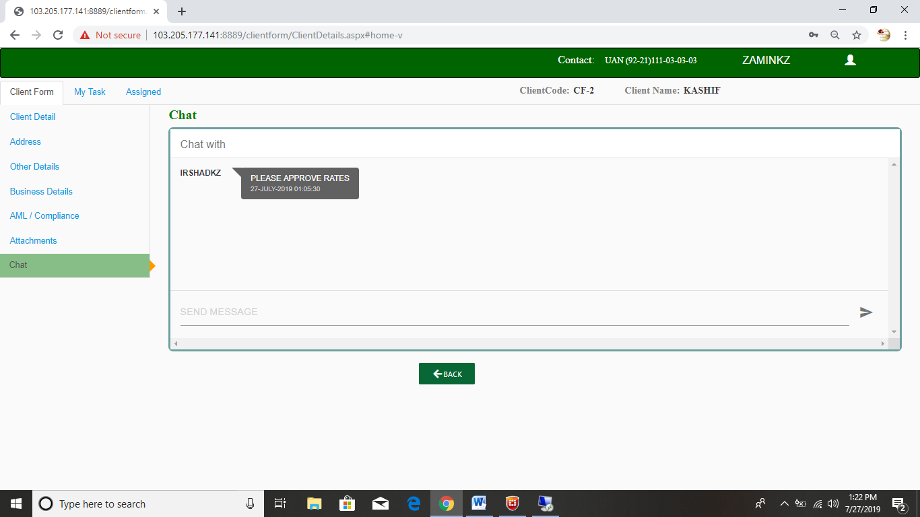

* Branch Manager Finalize client then Auto forward to Fawwad.

**Login for Fawwad**

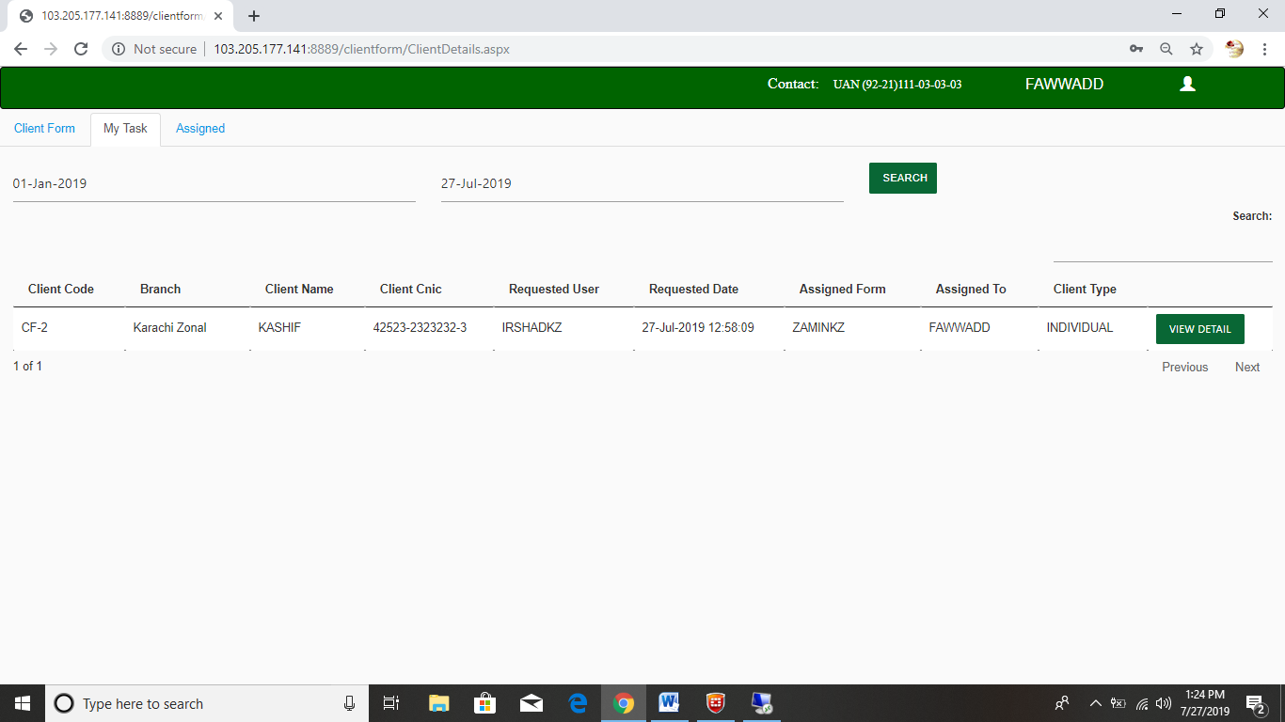

* Fawwad can be Revert to Branch Manager.
* Fawwad can be Forwardto Tariq or Omer Zubair For Further Approval.

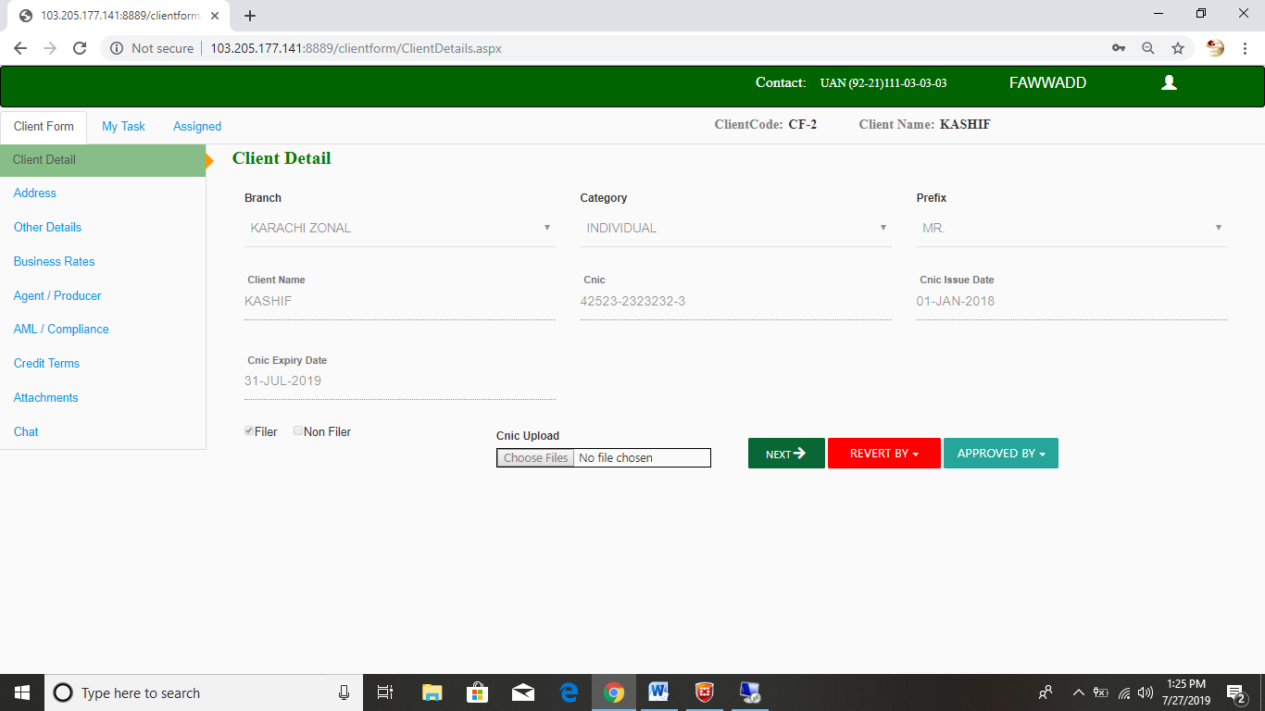

***Business Rate Approval :***

* Fawwad can be Edit Rate orApprove rate .
* Fawwad can be Finalize.

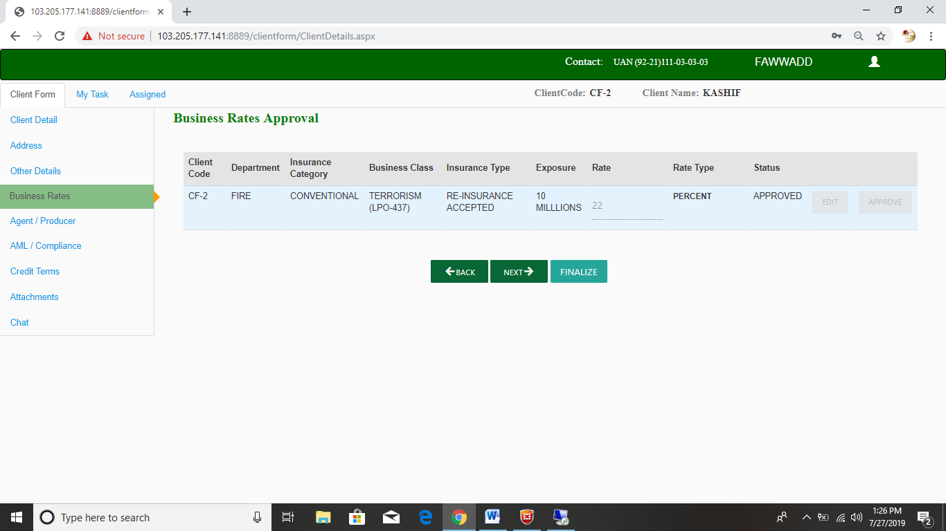

* If rate is “Standard” and installment is “Upfront Payment “ then Auto forward to AML or IT.

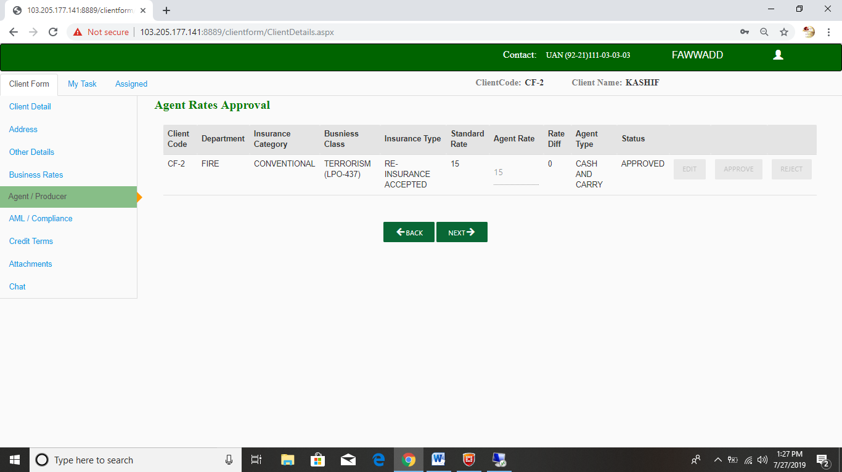

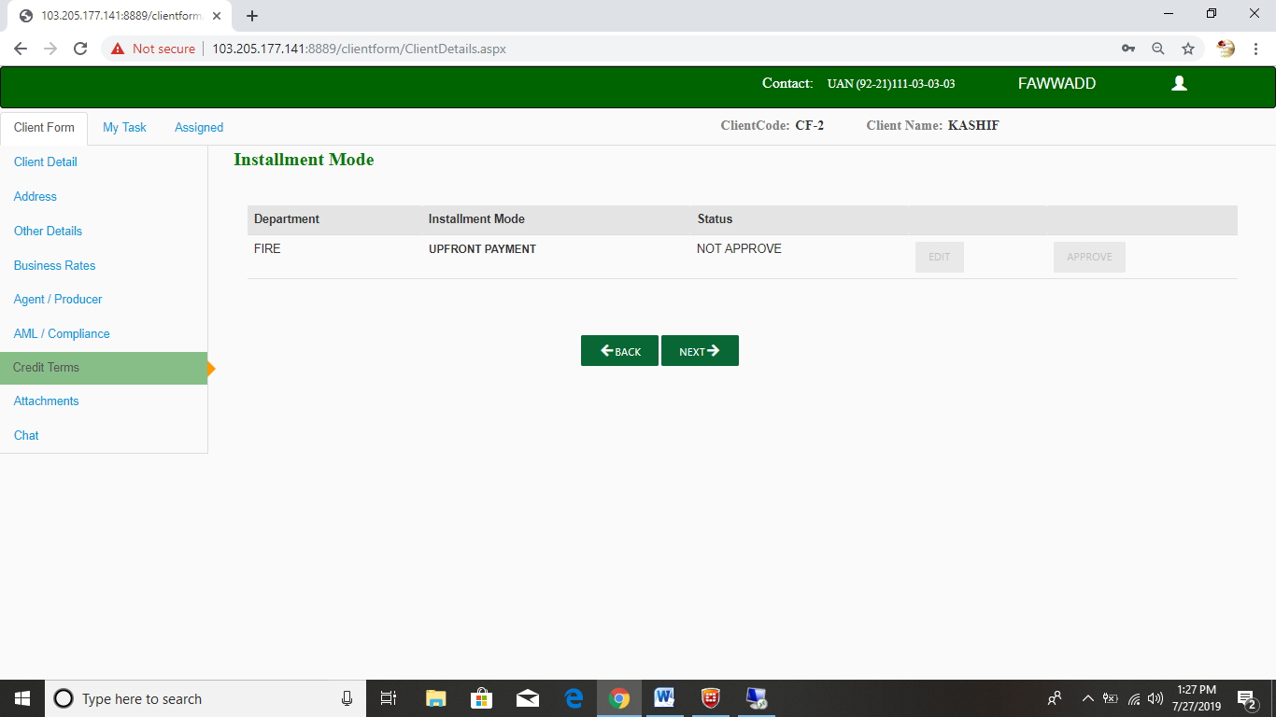

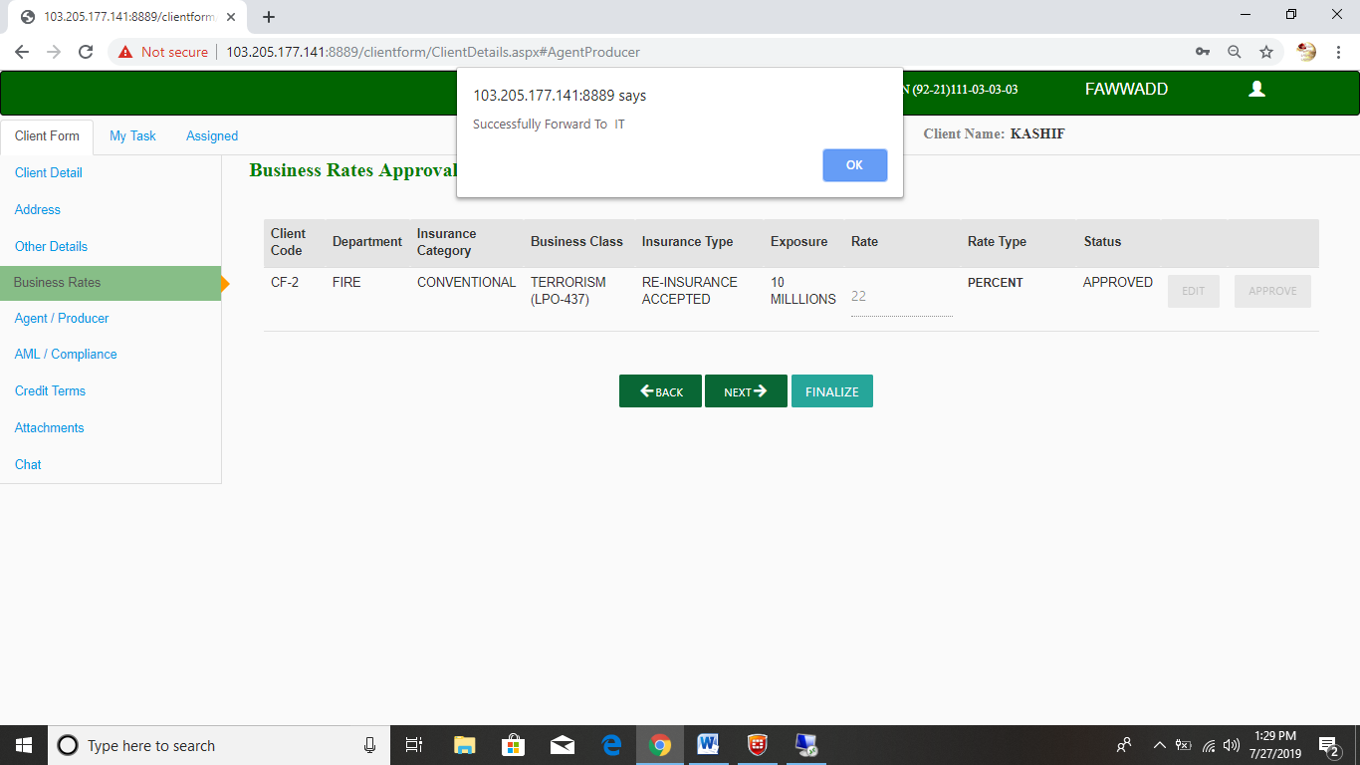

* If rate is “Over Commission” and Installment is “Upfront Payment” then Auto Forward to MurtazaHussain.

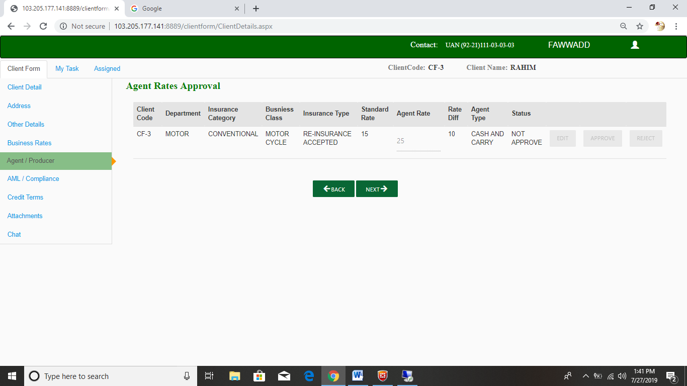

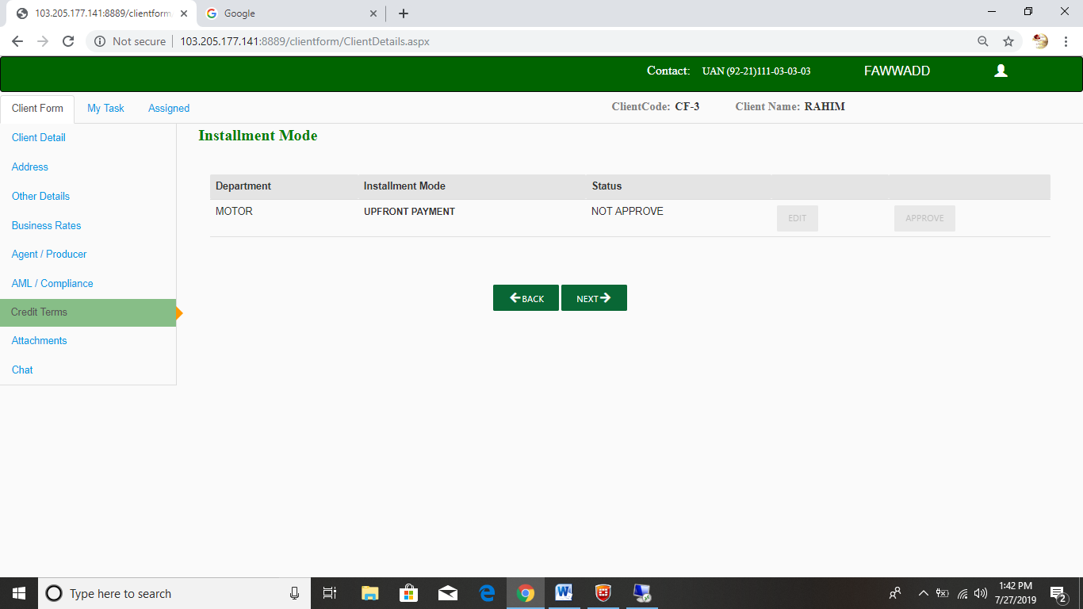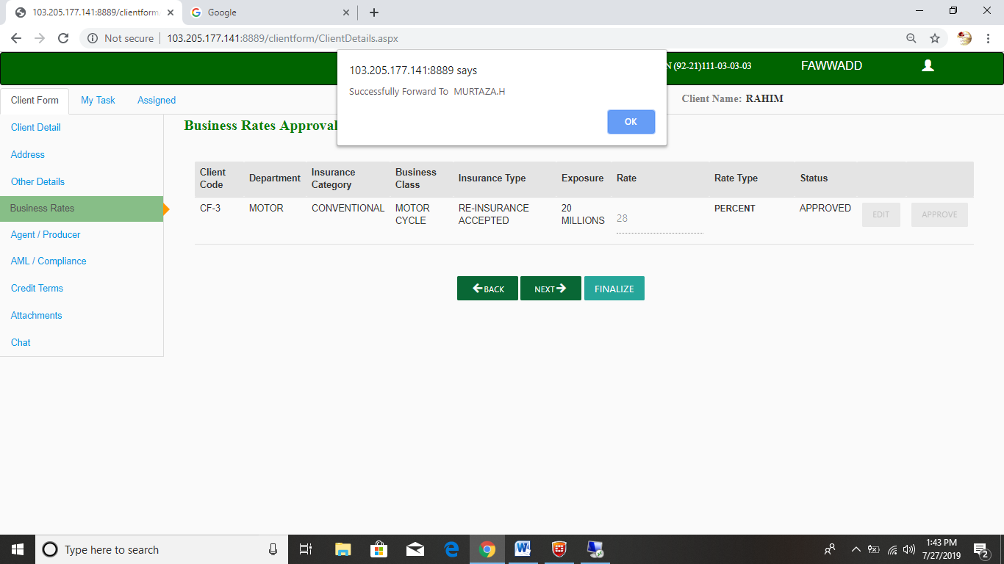

* If rate is “Standard” and Installment other than “Upfront Payment” then Auto Forward to ZeeshanLilani.

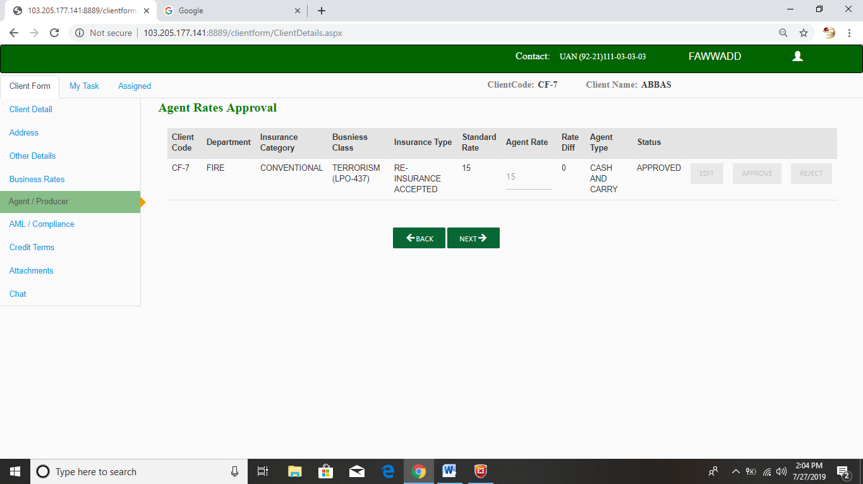

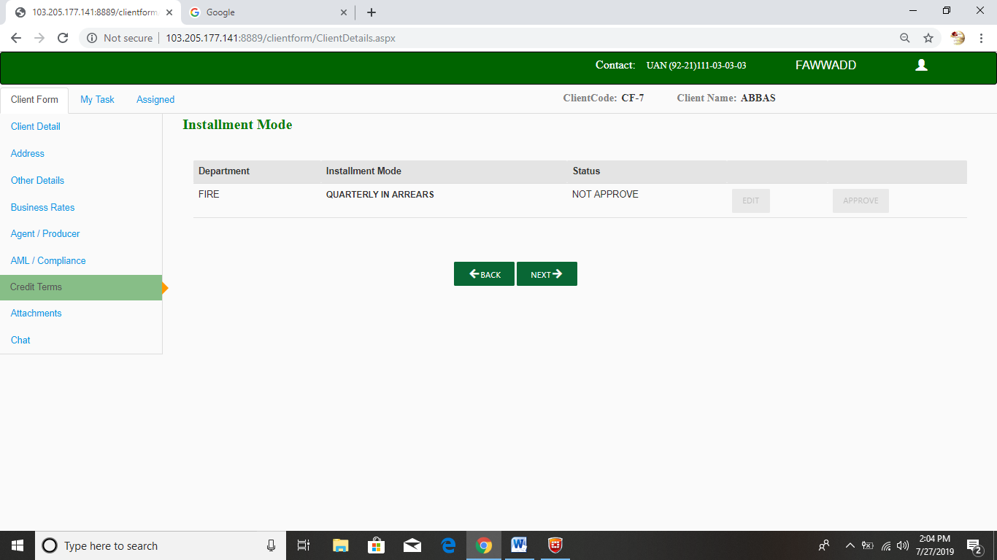

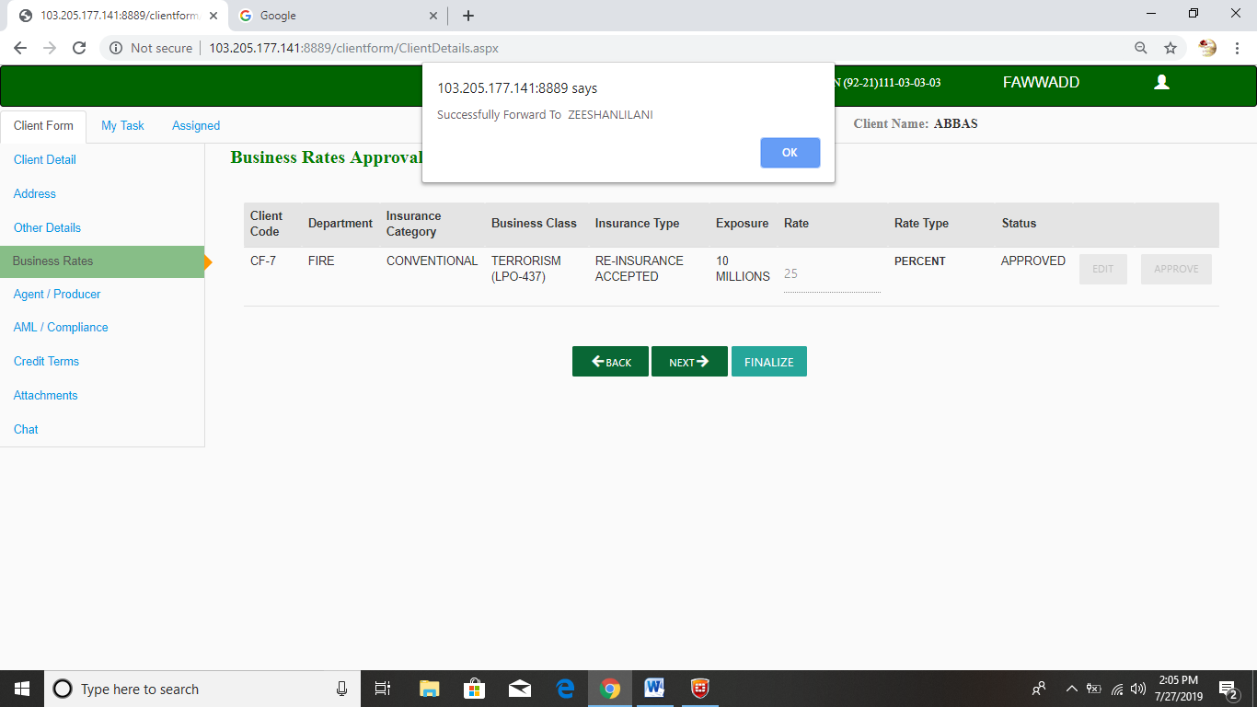

* If rate is “Over Commission” and Installment other than “Upfront Payment” then Auto Forward to MurtazaHussain and then MurtazaHussain Finalize then Auto Forward to ZeeshanLilani.

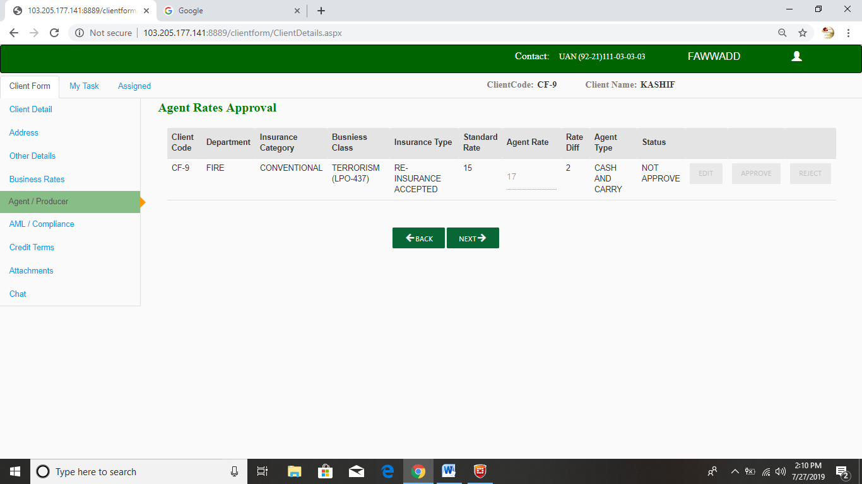

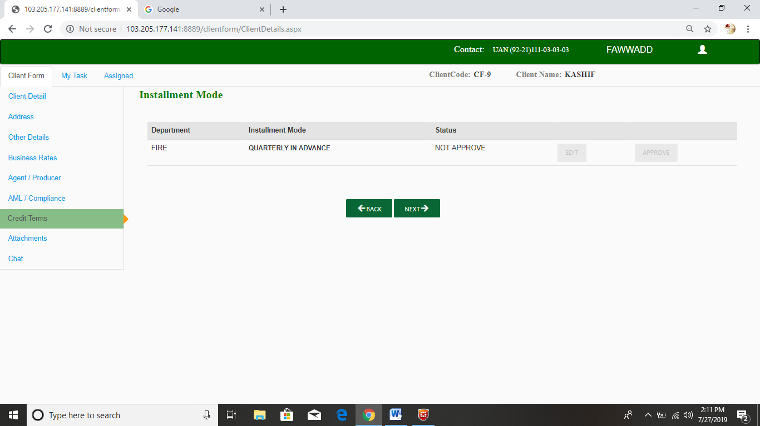

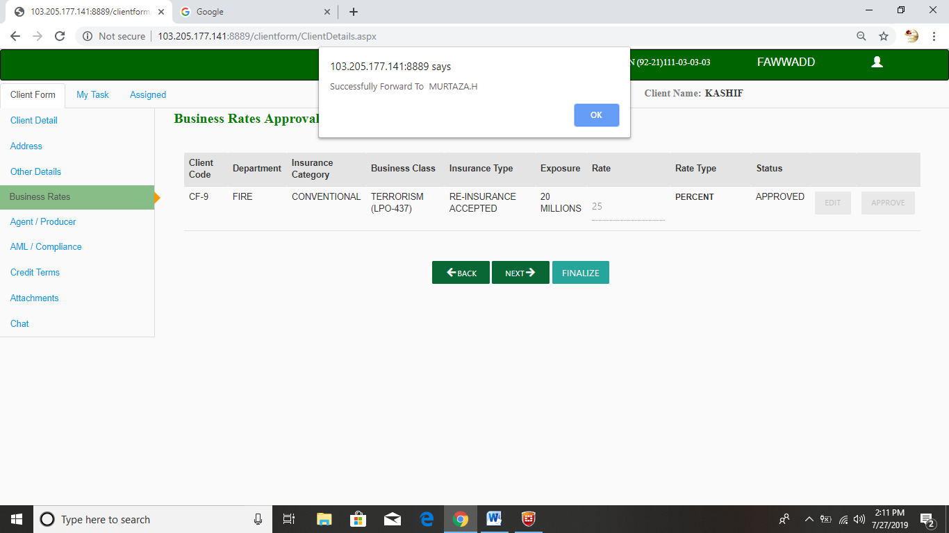

***Approval Screen Role Wise:***

***Business Rate Approval:***

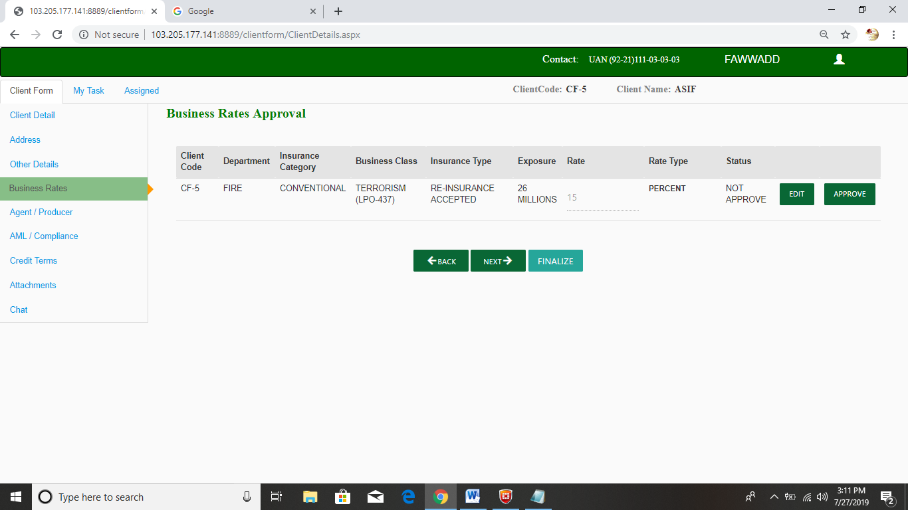

***Over Commission Approval:***

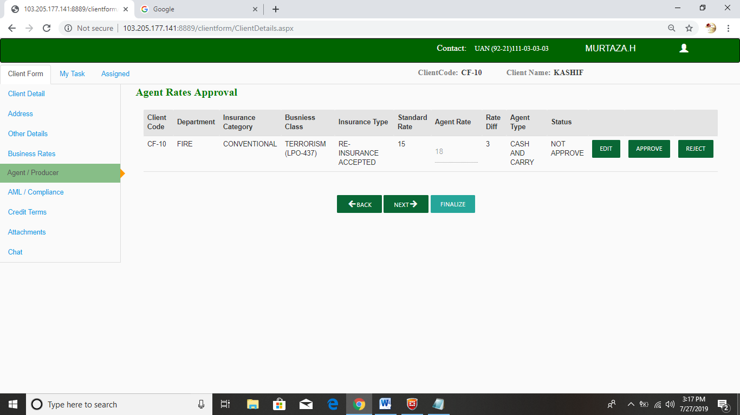

***Installment Approval***:

